Task on vpc

- Create VPC with 2 private and 2 public subnets.
First we need to create vpc –give name -- CIDR
Next enable DNS hostnames
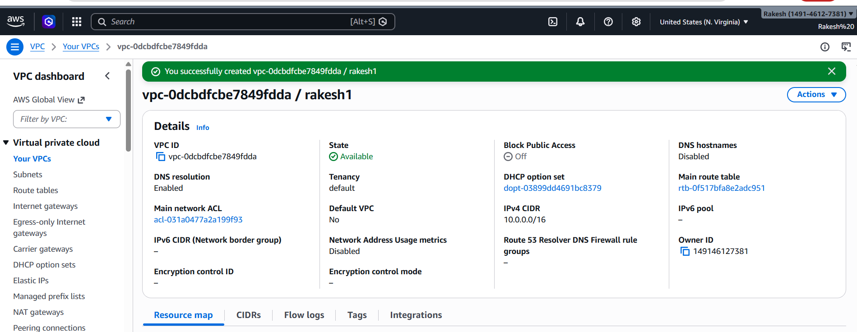
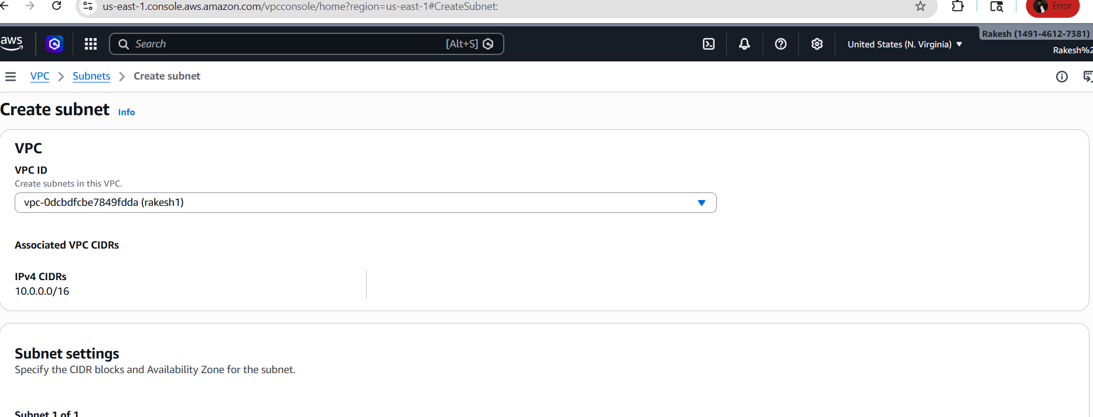
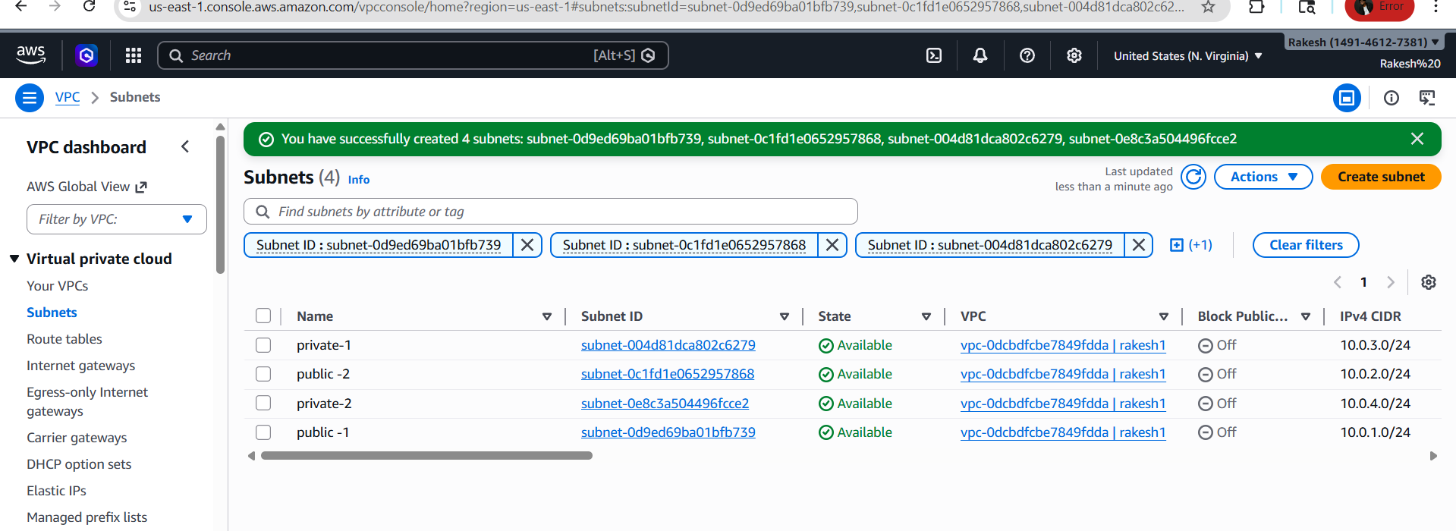
- Enable Auto Assign Public IP in 2 public subnets.
> Go to VPC Dashboard
-> Click on Your VPCs
->Select your VPC
->Click on Actions
->Select Edit VPC settings
->Enable DNS hostnames
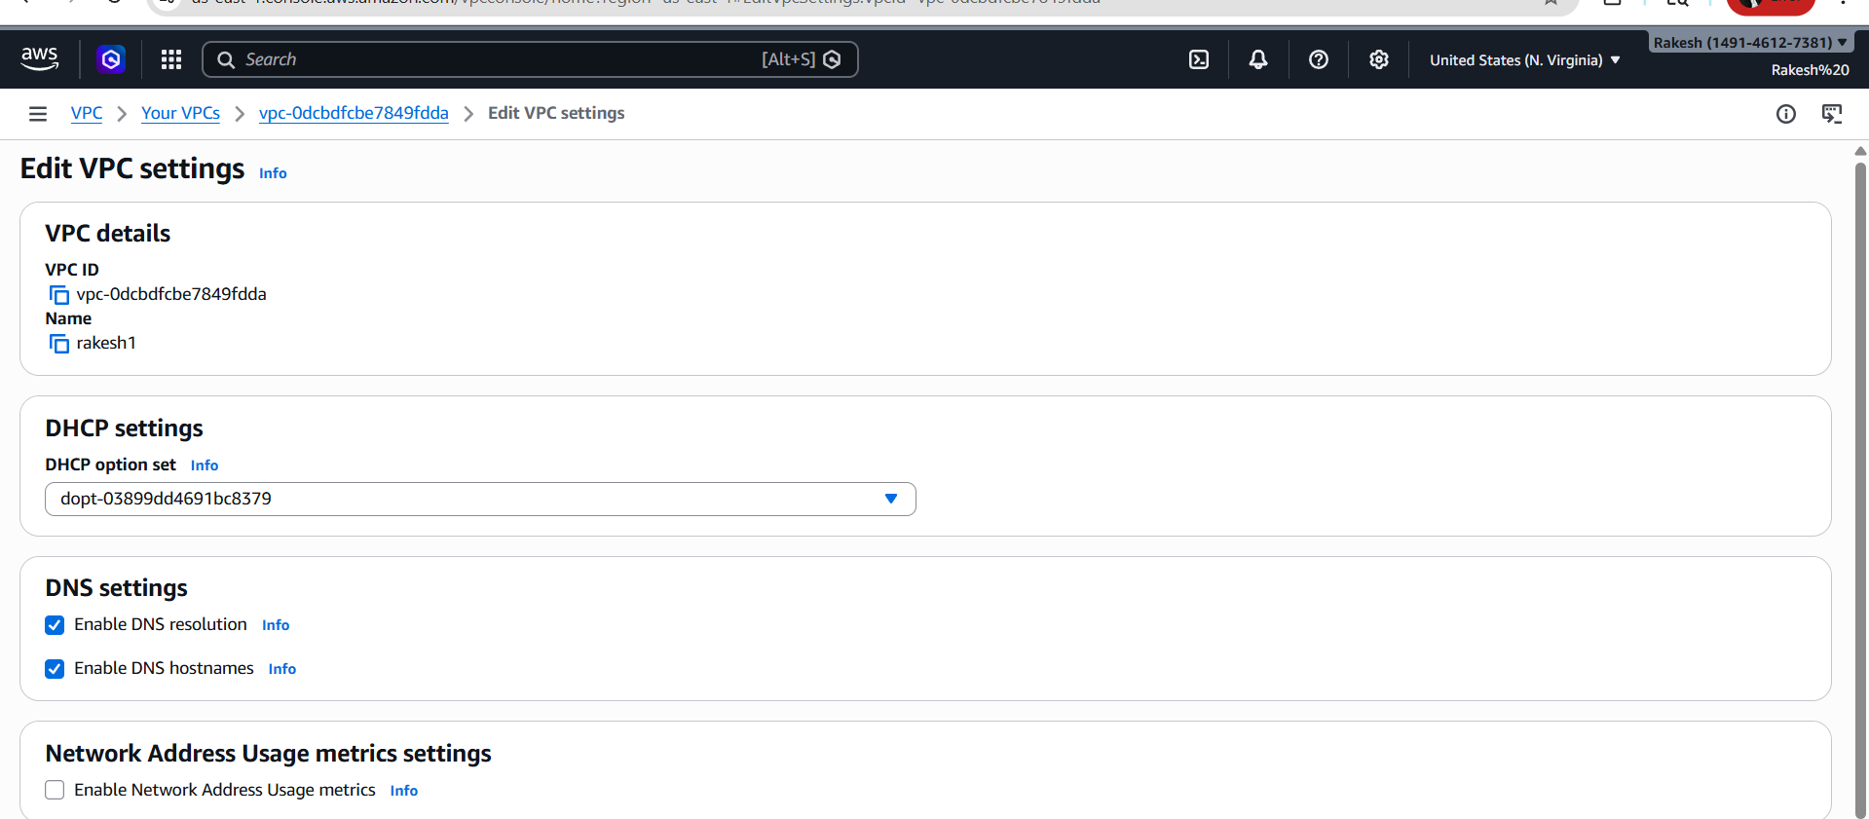

3. Enable Auto Assign Public IP in 2 public subnets.
> Go to public subnet
-> Click on edit subnet settings
->Enable auto assign public ip for both the subnets
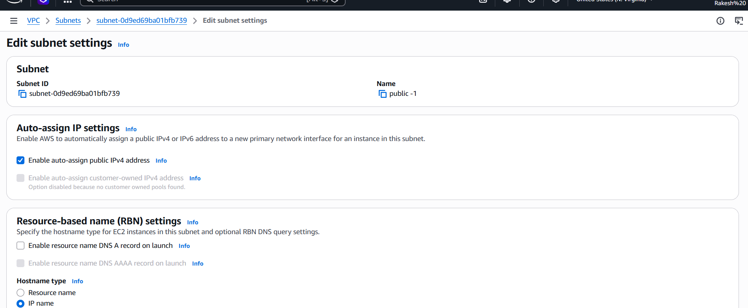
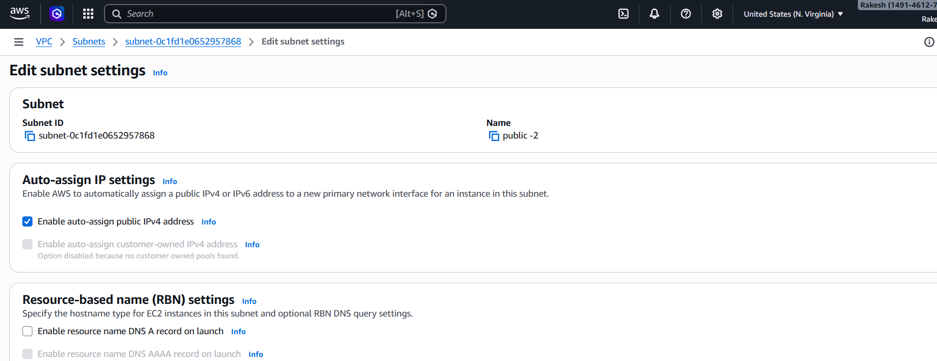

4. Add 2 private subnets in private route table.
->First created a private route table
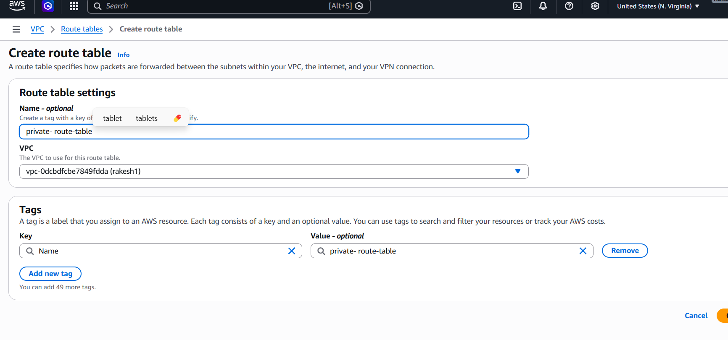

Edited subnet assosiations by adding two private subnets
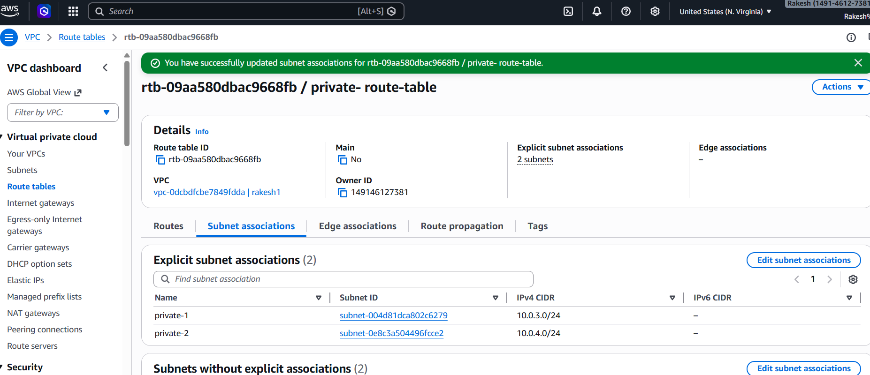

5. Add 2 public subnets in public route table.
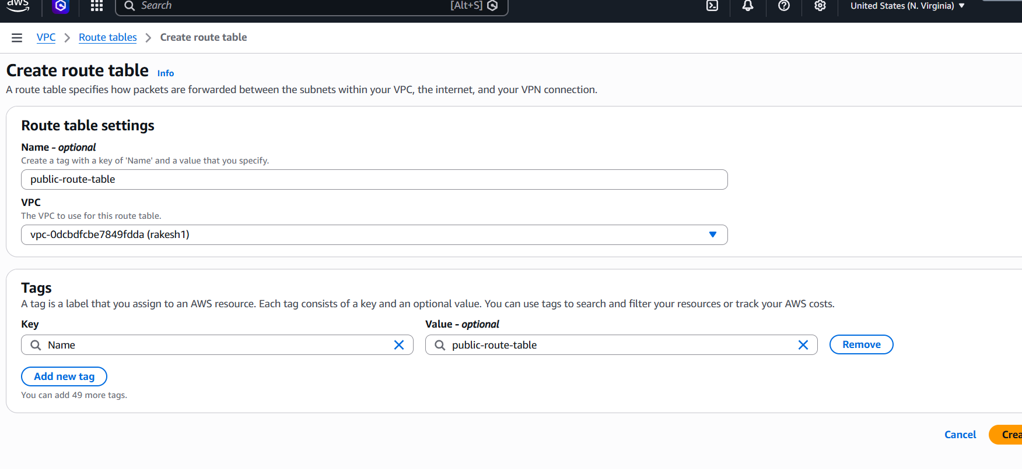

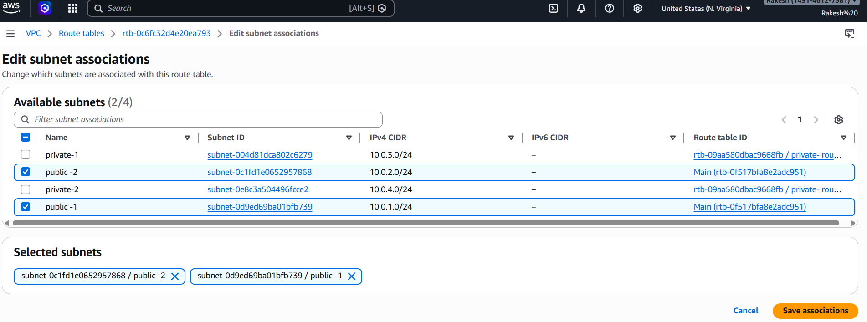
6. Public route table will have the routes to internet and local.

-> I have created a internet gateway
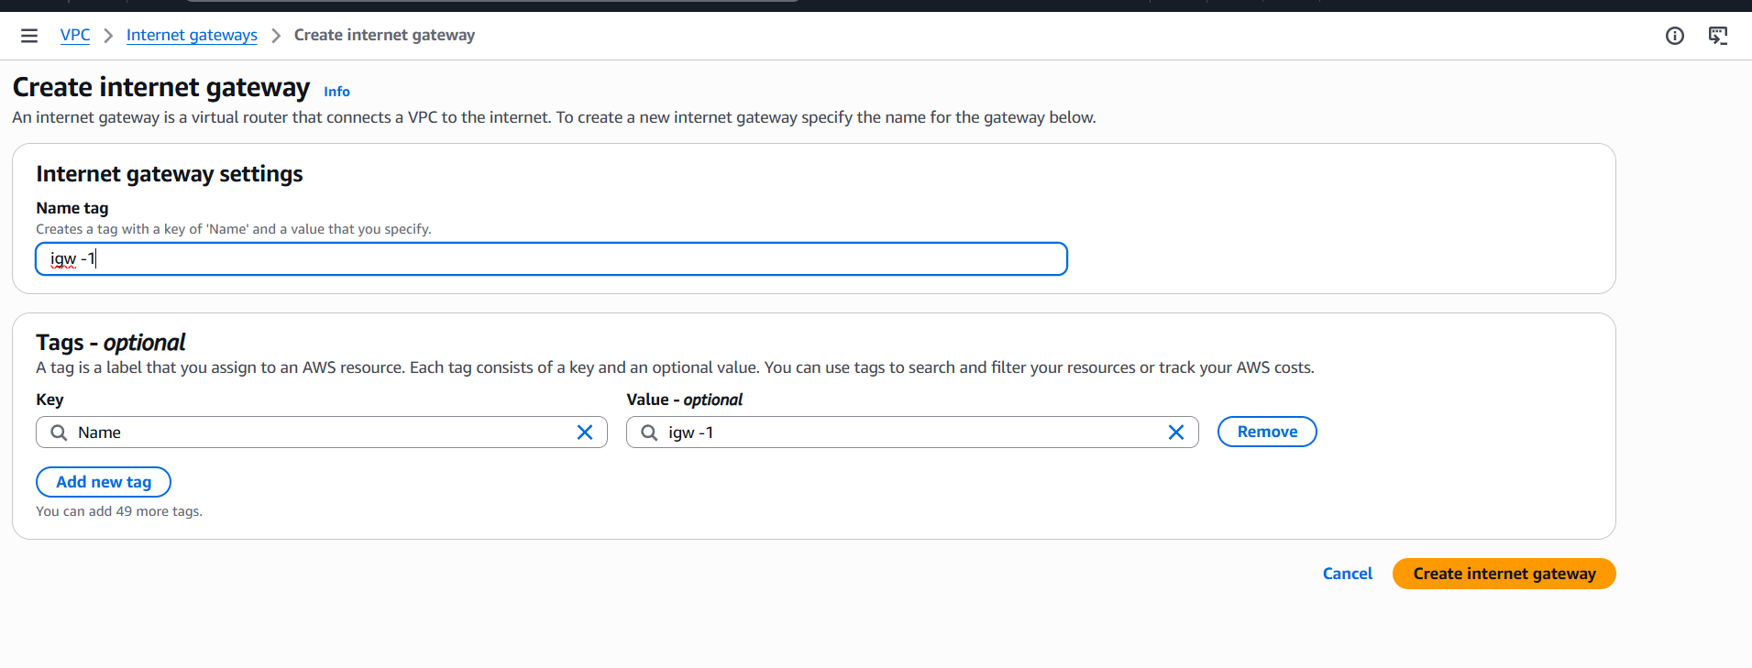
Attach igw to vpc
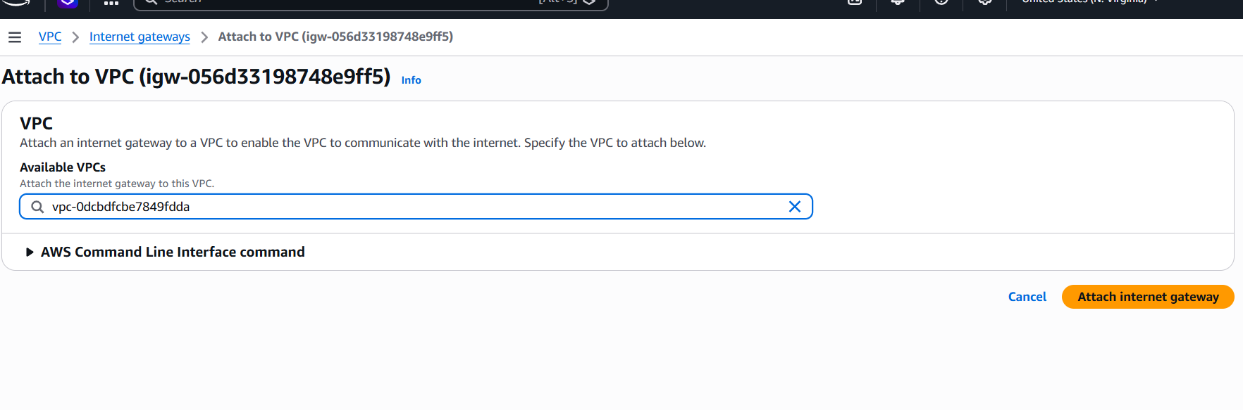

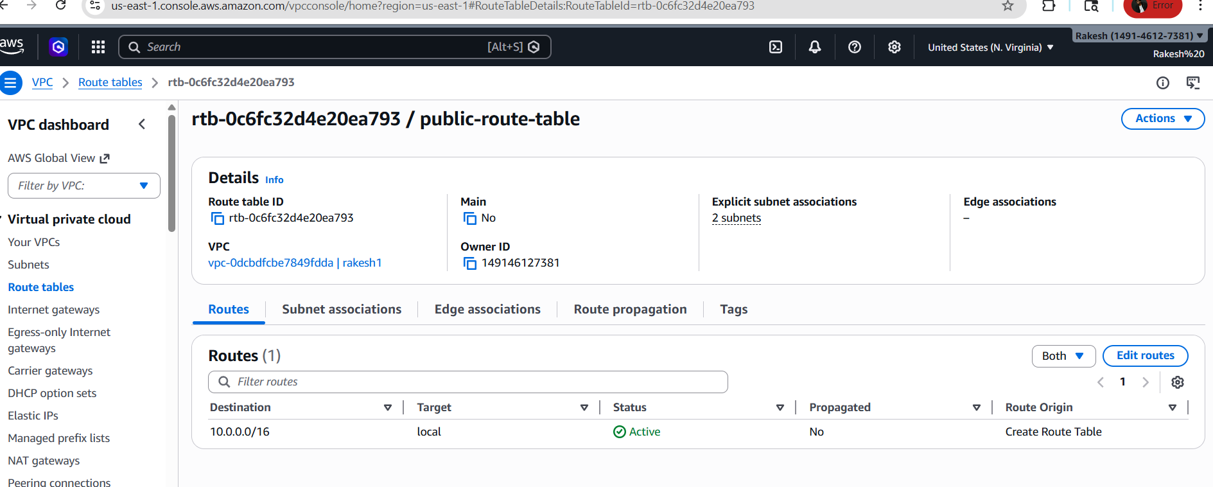 I have added routes by selecting edit route and saved changes
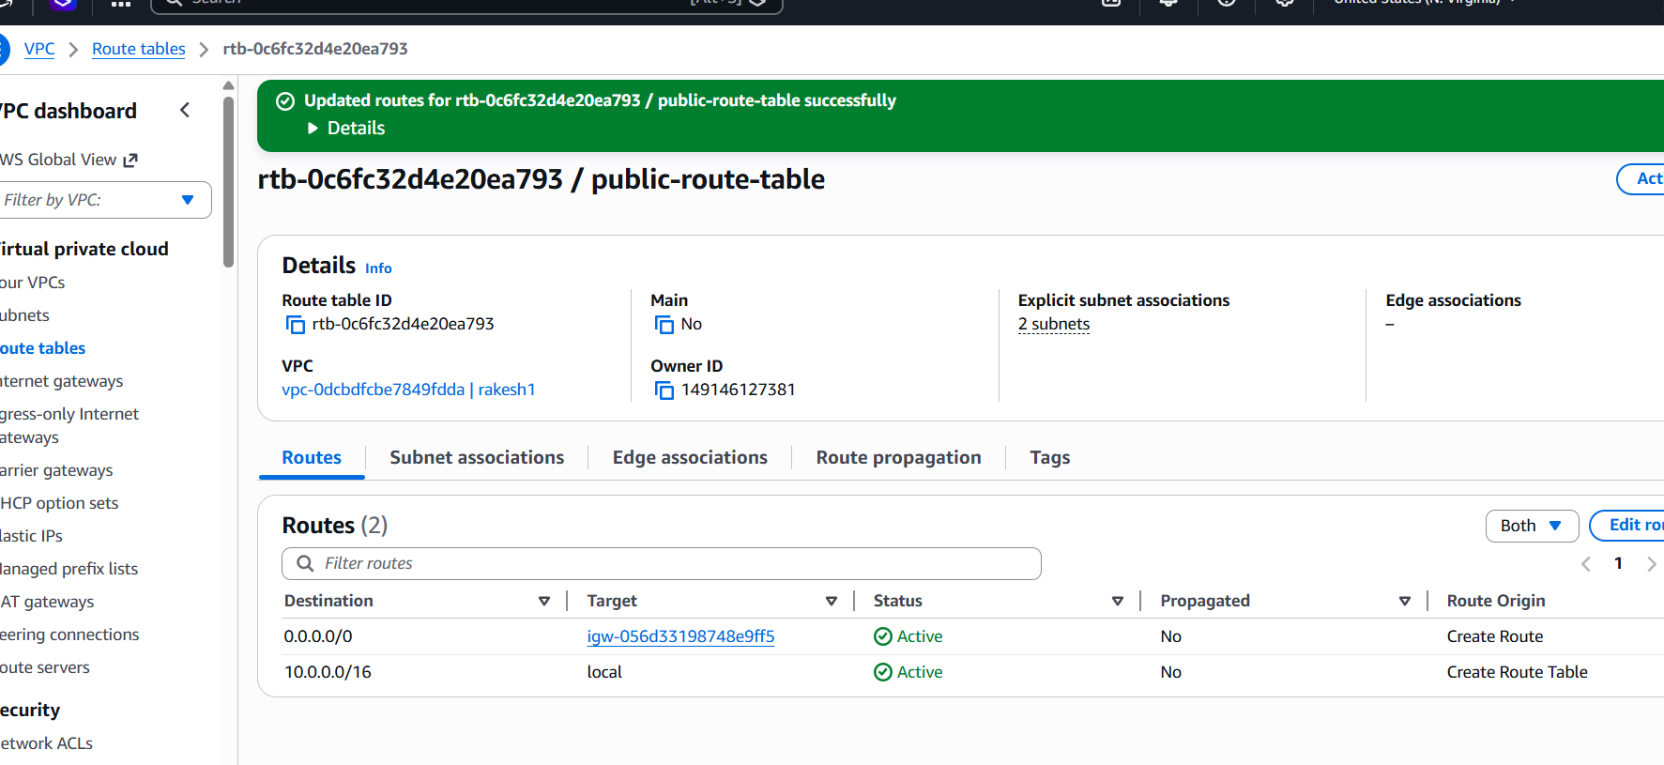

Viewed the route table

7.Create EC2 in public subnet with t2.micro and install PHP.

-> Launched a new instance
-Under Network Settings:
VPC: Select your VPC (MyVPC)
Subnet: Select public-subnet-02
Enable Auto-assign Public IP
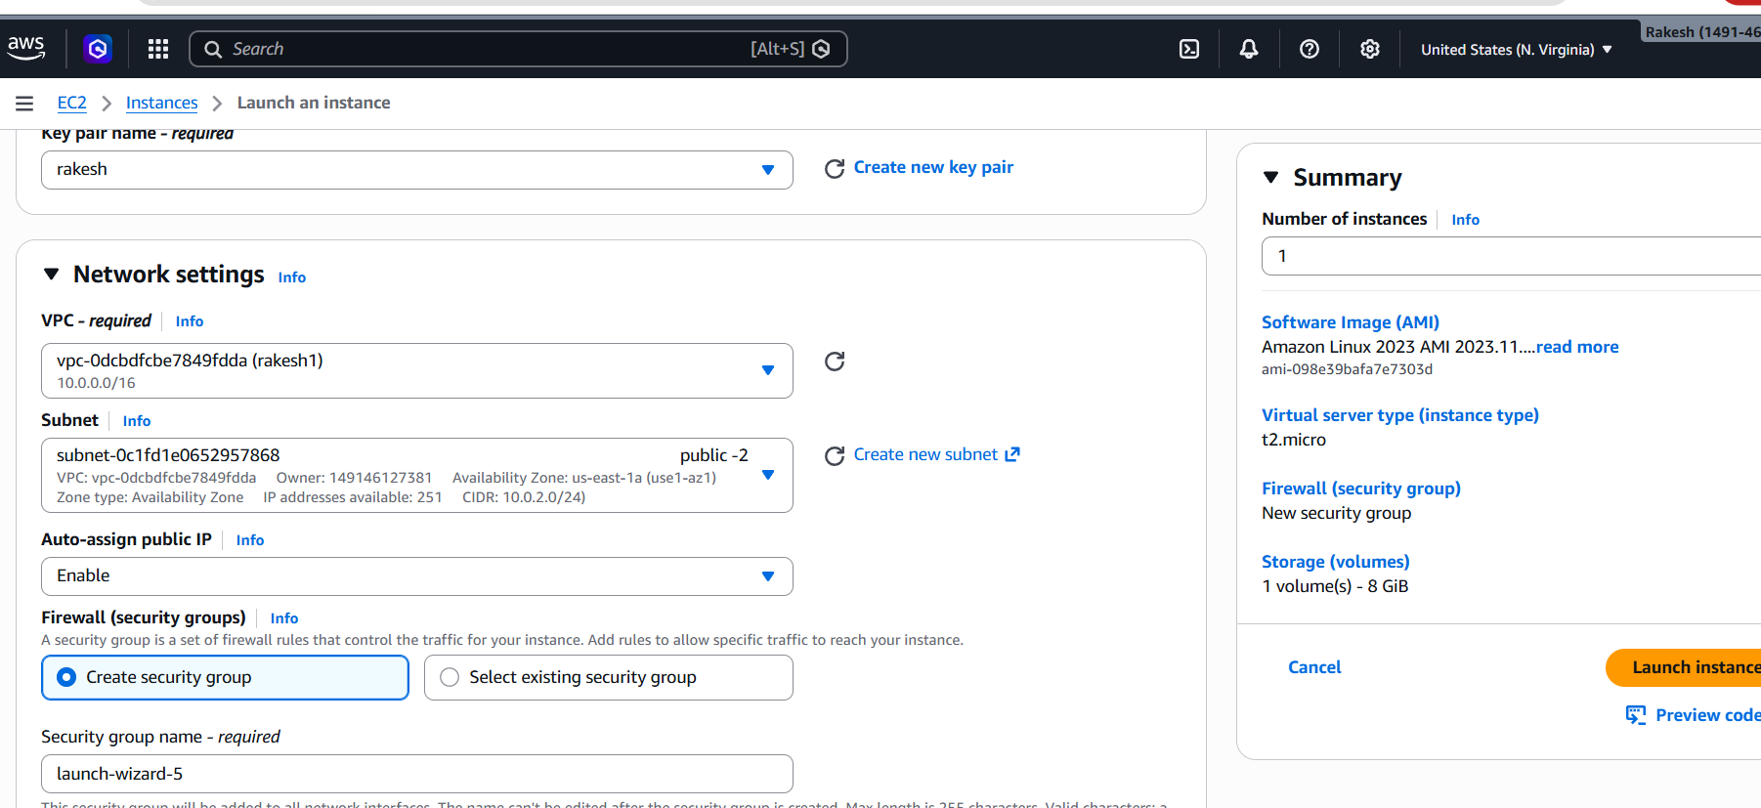

I have connected EC2
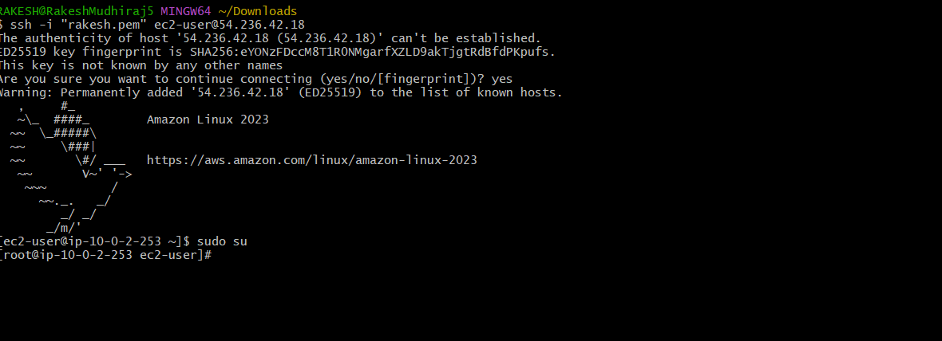

installed PHP with the below commands
- sudo yum update -y
- sudo yum install php
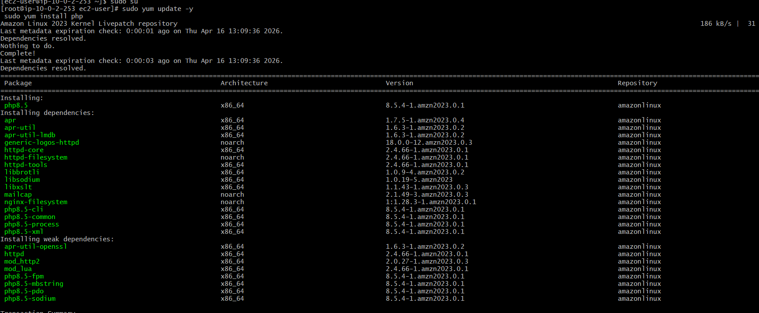

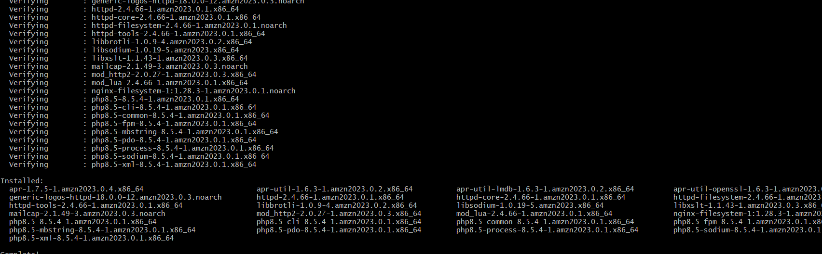

8. Configure NAT gateway in public subnet and connect to private
instance.
-> Create NAT gateway
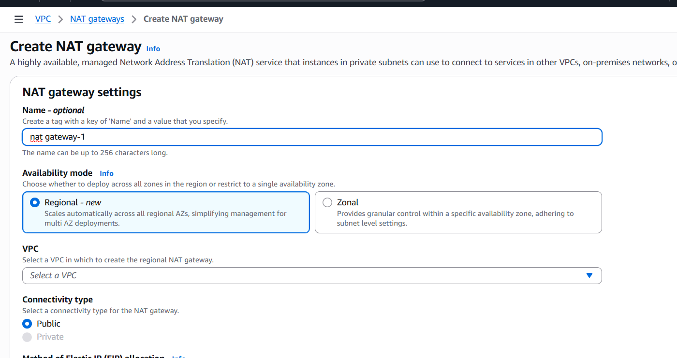

Update Private Route Table
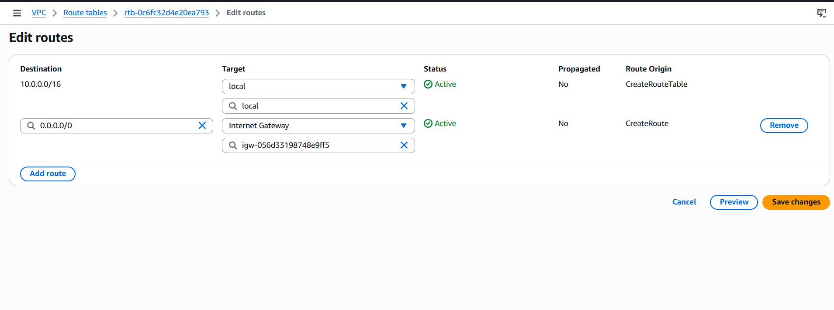
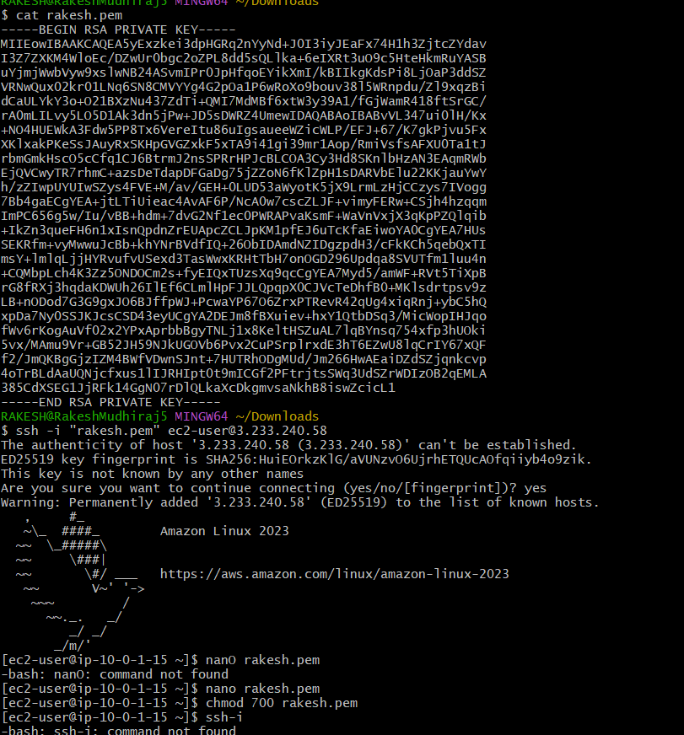
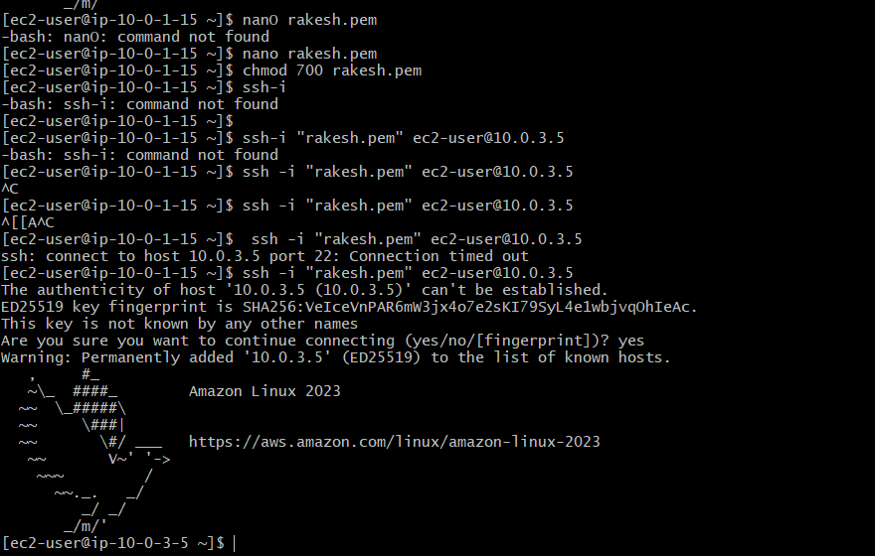

9.Install Apache Tomcat in private EC2 and deploy a sample app.

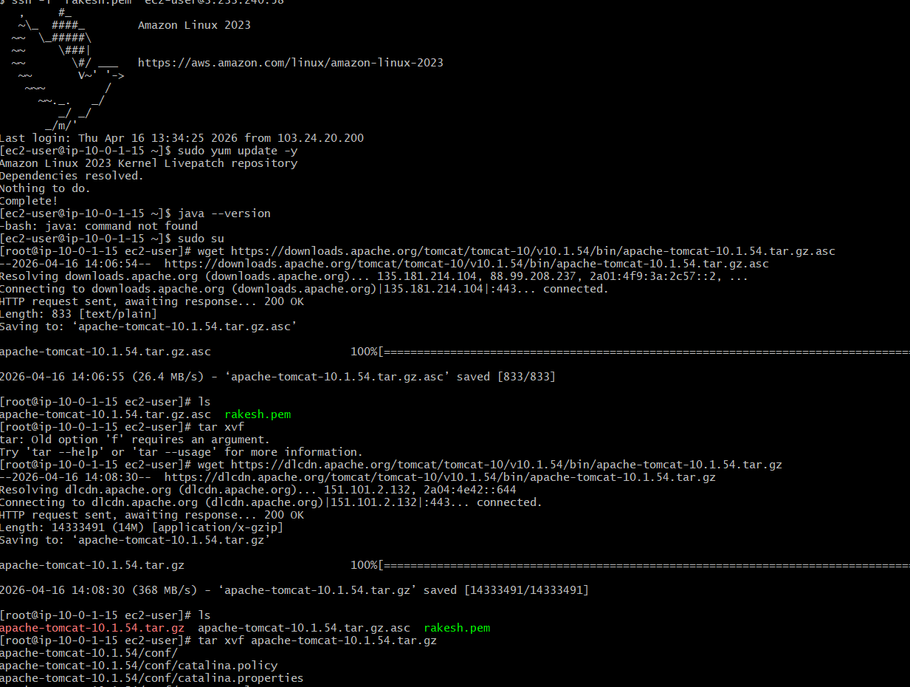

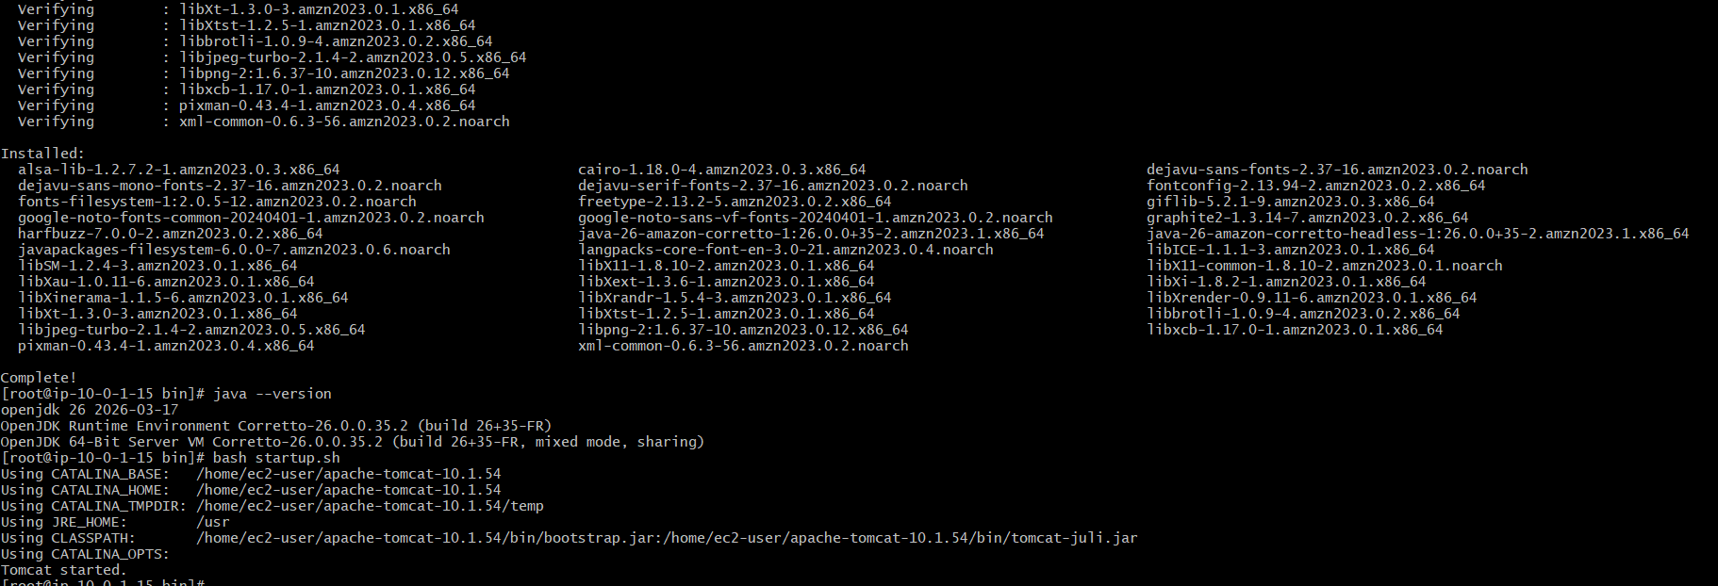
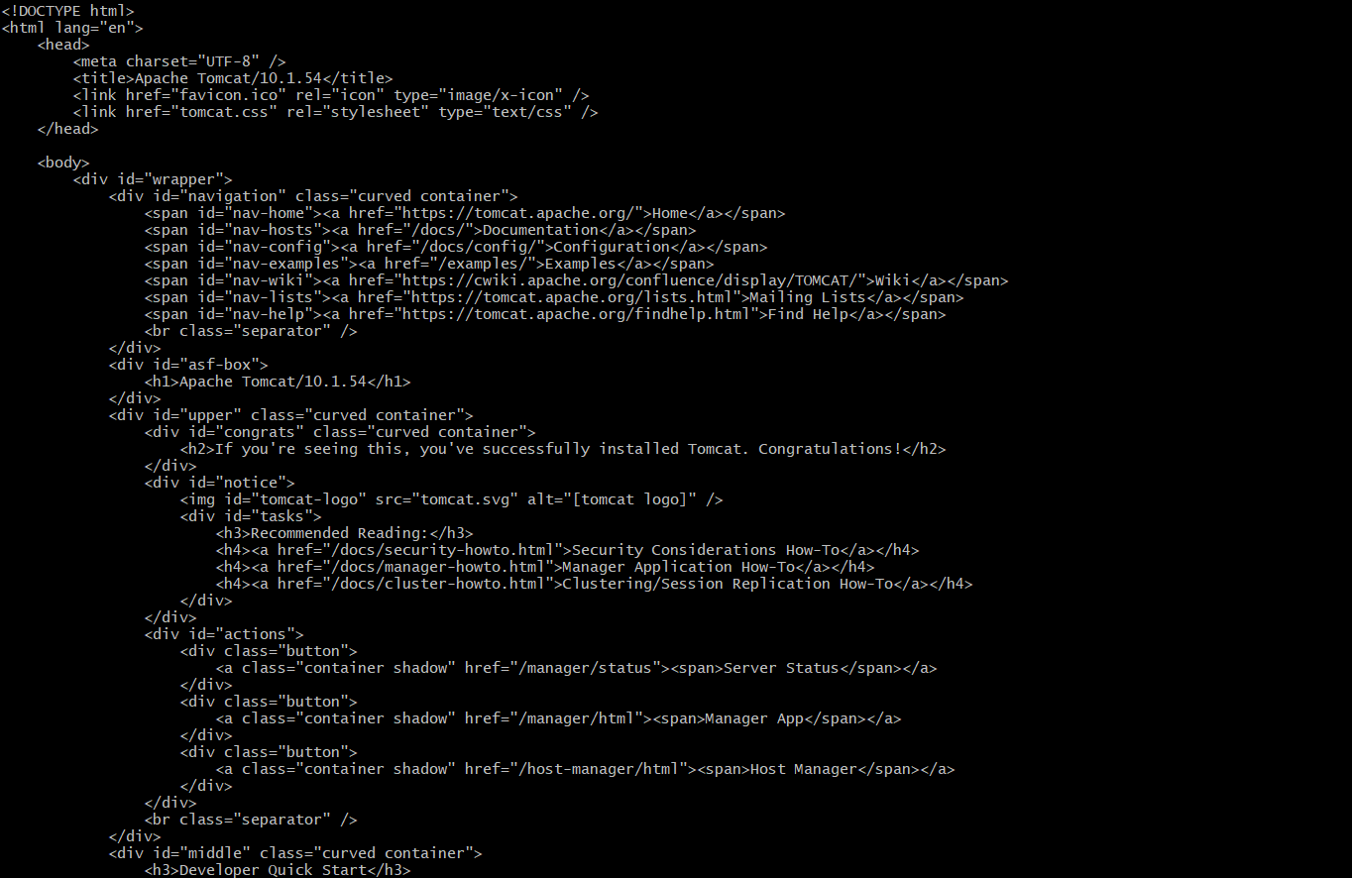
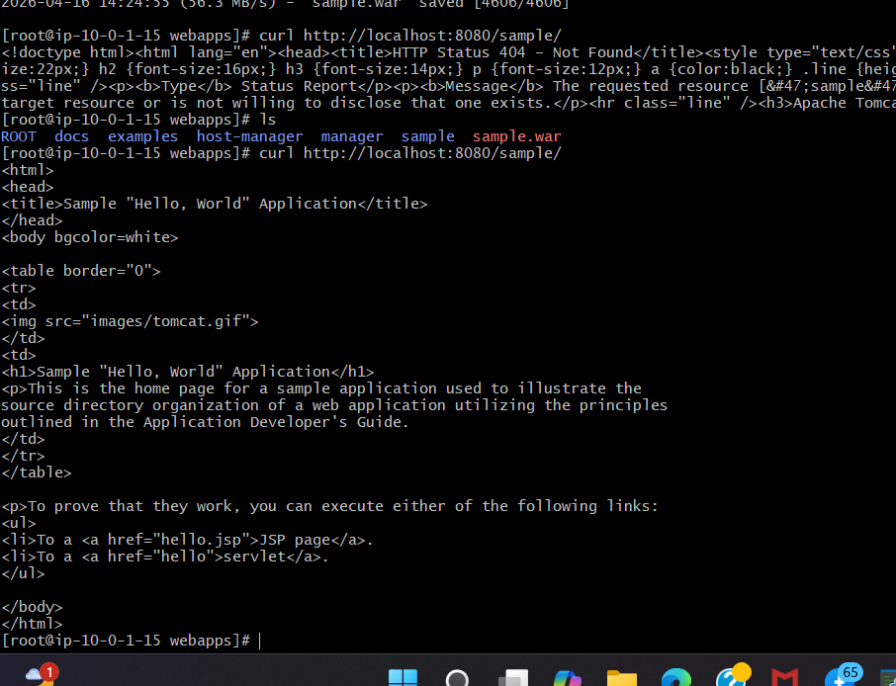

10. Configure VPC flow logs and store the logs in S3 and CloudWatch.
->Create S3 Bucket (for logs)
->Create Flow Logs for VPC
->Create Flow Logs for S3
